Private Dining Reservation System

Overview

The purpose of Private Dining Reservation System is to book a private space (eg rooftop, room, cabin) for their private party. This reservation system should be designed for a group meeting a min-capacity requirements by the restaurants.
This application is used by guests (creating/ updating and cancelling reservations) / restaurant staff (to approve or cancel reservations).

Assumptions
- User/Role registration and authentication is out of scope
- Restaurant Id is unique in system
- Room id is unique in system (although all checks for checking room belongs to restaurant is still there)
- Min duration of booking is 3 hours
- The uniqueness of the restaurant is from restaurant id, same name restaurant is allowed.
- In ideal scenario (geolocation of restaurant with restaurant name should be used for uniqueness) which is not possible to have in scope of assignment (Change of ownership can let email, name, contact change, hence we cannot make it unique based on this)
- Adding Rooms with the same name is possible and Room id is a unique identifier as room number.
- Cancellation should be done 24 hours in advance.

Functional Requirements

1.1 Restaurant & Private Room Management
- Create/ Update/ View Restaurant
- Restaurant Staff can create a restaurant entity into the system
  - Fields: restaurant_name, address, contact, email, local_currency_code
- Restaurant staff can update their restaurant details into the system
- Diners can view their restaurant details in the system
- Create/ Update/ View Rooms for restaurant
- Restaurant staff can create rooms for restaurants in the system, basically adding the rooms they have in the restaurant.
  - Fields: room_name,restaurant_id, min_capacity, max_capacity, group_size, min_spend_in_cents
  - Restaurant staff can update rooms for restaurants in the system eg (decreasing/ increasing capacity etc)
- Diners can view the list of rooms configured for a restaurant in the system.

1.2 Reservation Management:

1. Create Reservation
- Diners can create their reservation in the system
  - Fields: room_id, restaurant_id, reservation_date, reservation_start_time, reservation_end_time, diner_email, group_size
  - Conditions: Room available for restaurant at given time slot, Within Capacity limits.
- Check for Room availability before confirming.
- Prevent Double Booking

2. View Reservation
- Restaurant Staff can view the reservations
- Diners can view their reservations

3. Cancel Reservation
- Restaurant Staff can cancel the reservations
- Diners can cancel their upcoming reservations.

4. View Availability
- Diners can view the available slots for a specific date and time to block and create reservations.
  - Conditions: Group Size should be accommodate
  - Slots are available at specific date and time.

1.3 Event Driven:
- Publish TableReservedEvent, once the reservation is confirmed.
- Subscribe to TableReservedEvent event, and send or log a confirmation message.

Non Functional Requirements:
- Scalability
- Latency
- Throughput
- Concurrency requirements
- Availability
- Data Integrity

System Architecture

Context Diagram

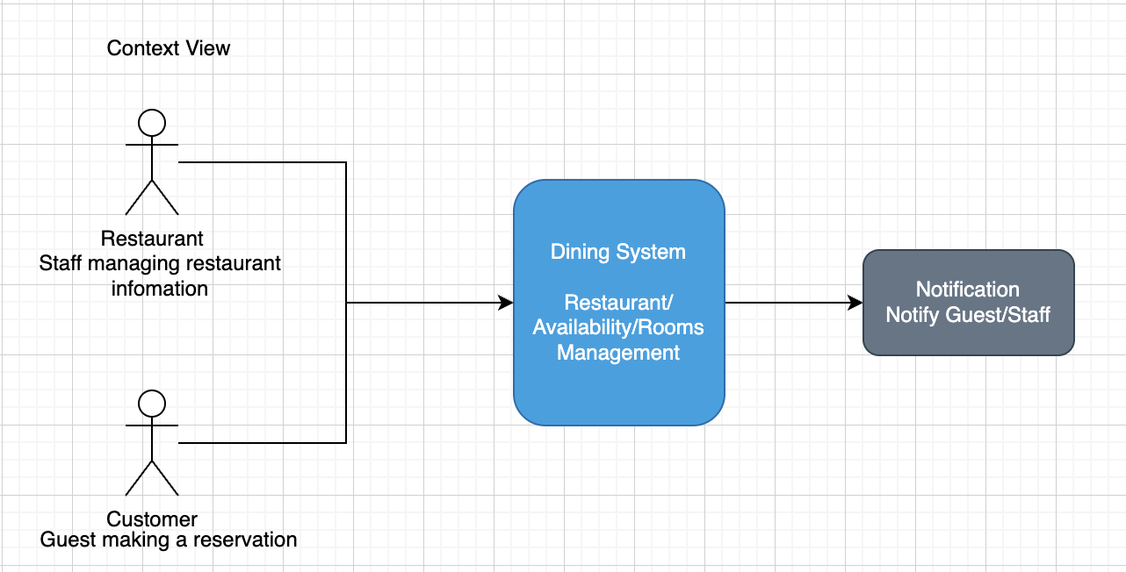

Container View
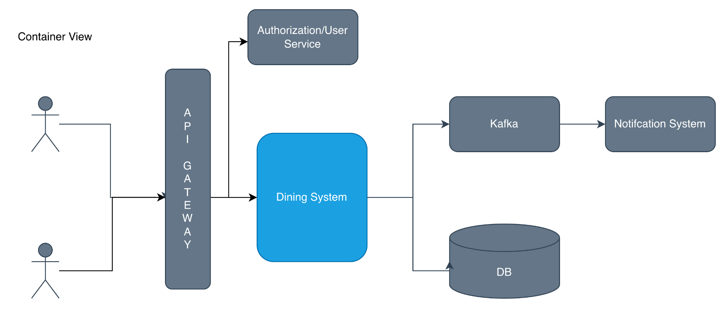

Component View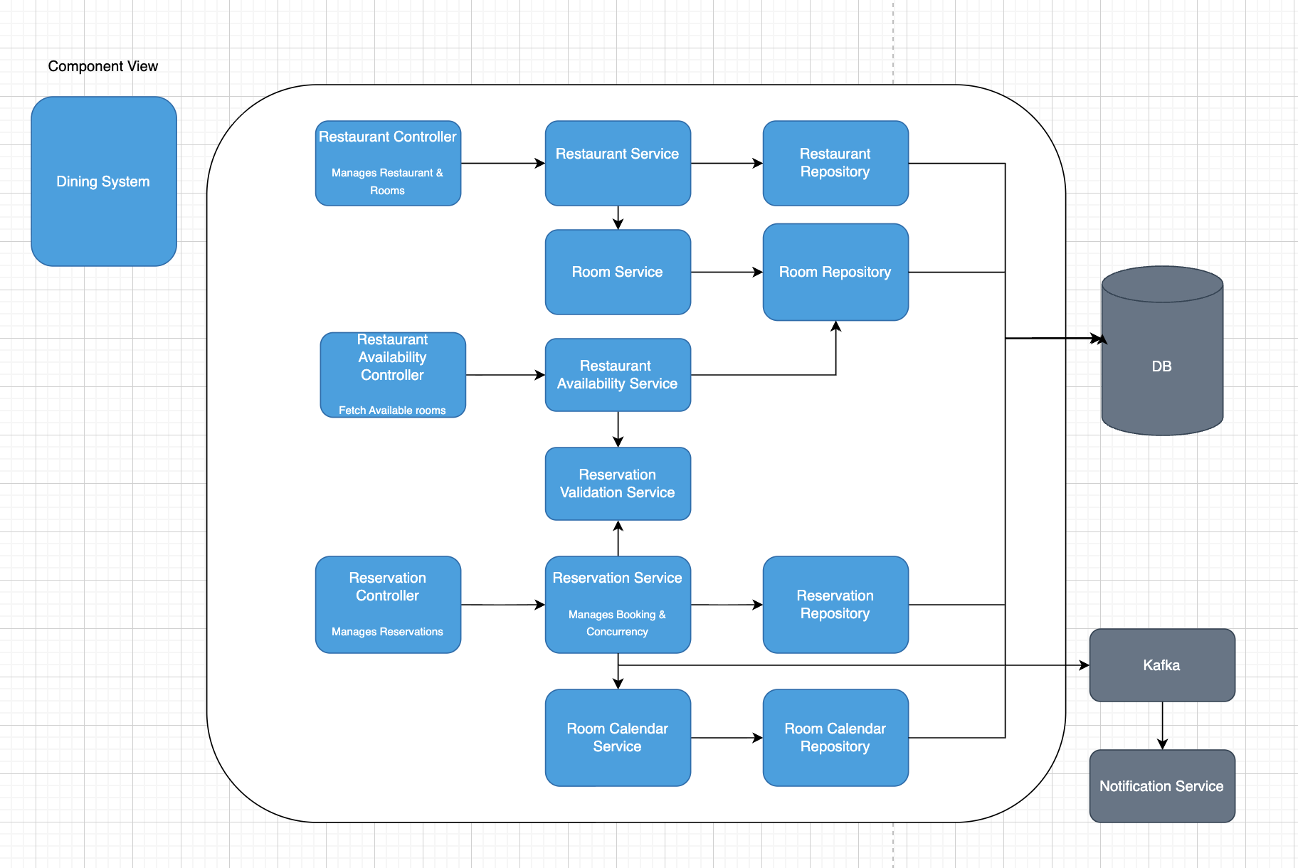

Database Decision

ADR: 1 Database Decision

ER Diagram

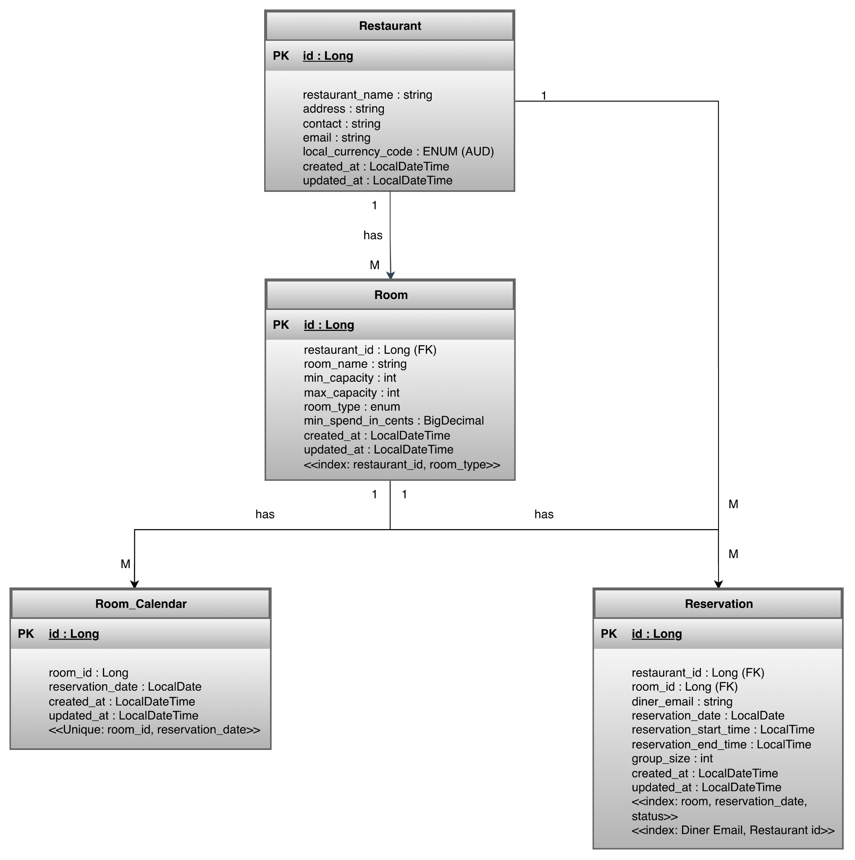

Approach Decision

ADR-2: Concurrency Control Approach Decision

API Design

Eg: Create Reservation
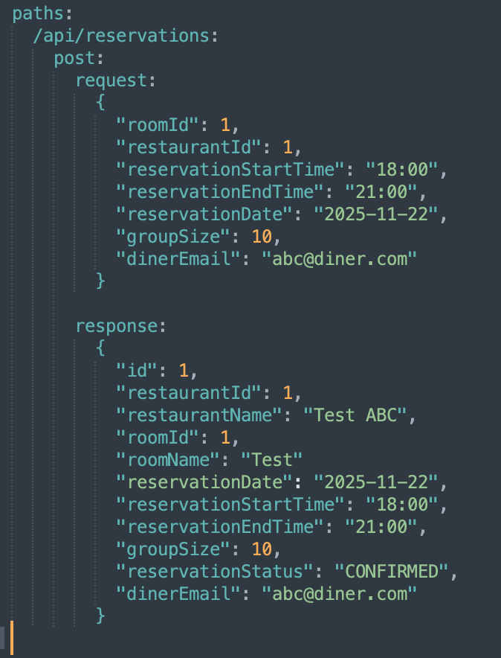

Please refer to Api Specs for all exposed API’s.

Proposed Event Driven Architecture

Scalability Plan

To scale the current approach, we can create segments based on room_id, reservation_date, slot_start-slot_end and the appropriate pessimistic lock.
The advantage of using this approach is that for reservations of the same room_id, same reservation_date, you just need to acquire their specific time slot lock and the rest of the reservations of different slots can still proceed in parallel.

Improvement Plan
Availability Service can be empowered by the cache or read replicas to avoid the load on the main Reservation Service.

